# *Lab 3 – Interview Preparation; Requirements Gathering*

Date assigned: Friday, September 16, 2016

Date due: **Friday, September 16, 2016, 12:00 p.m.**

**Learning Objectives**

Upon successful completion of this lab exercise, the student will be able to:

* Better understand the requirements gathering technique of interviewing
* Determine the appropriate requirement gathering techniques for a situation
* Distinguish between functional and non-functional requirements for a system

Part 1 – HVK Interview Preparation

To do:

**This section is to be completed with your group. Submit one document per team.**

1. With your group, review the HVK documentation and the business rules that you developed. Review the interview techniques discussed in class.
2. Create interview questions to interview Jim and Sally Read. Organize the questions and leave space so that you can record your answers. You may need to ask questions:
3. That help you to understand requirements that you do not completely understand (things that may be confusing when you try and figure out how to implement them);
4. To get more details on requirements that are missing or incomplete; and
5. To get the requirements for the new things that the Reads do not do now, but would like to do with the new system (the cattery, registration over the web, etc).
6. Include Close-Ended, Open-Ended and Probing questions. Your goal here is to gather the requirements that you are missing, the requirements for the web system and the requirements for the cattery.

Part 2 – Requirements Gathering Techniques – Complete Individually

Save this document as a Word document named **YourUserName_E11_L03_Interview_Prep.docx** in your 420-E11 folderin your home drive. The document will hold your answers for your lab.

1. For the HVK Case Study identify which requirements gathering technique(s) would be appropriate and which ones would not, justifying your answer. Specifically discuss interviews, JAD, questionnaires, document analysis, observation, domain research and prototyping.

Interviews: This is an appropriate method of information gathering because the number of people using the system is relatively small. Doing an interview you can get more specific answers to your questions.

JAD: This technique would also be good since it involves very close cooperating with the client. This is good for HVK since there’s a small group of people who need to be working with us to determine their needs.

Questionnaires: This might not be the world’s best technique for HVK since there’s a small group of people we need information from and Questionnaires are better for getting information from a large group of people.

Document Analysis: This is probably a good idea since the system is relatively small and contains only 4ish documents. Analyzing the documents gives the developer a good idea of what the final model of the system needs to look like since they know they need to include everything inside the documents.

Prototyping: Probably a good idea to do prototyping. Again, it’s a relatively small system, so building prototypes for the clients to test would be the best way I think to have user satisfaction. You also have a small set of users, so having a couple people test out the system wouldn’t be too hard.

1. Suppose you are the analyst charged with developing a new system for the College bookstore so that students can order books online and have them delivered to their house. What requirements-gathering techniques will you use? Justify your answer.

For this one you’d probably use questionnaires so that you can get an idea of what the students want since there’s so many of them. Send out a survey through omnivox and ask them to fill it out and then determine the user needs based on the survey results.

You might also want to do document analysis since it’s much harder to get information from people using the system. There’s a lot more people using it, so you probably need to do more information gathering on your own.

Deploying a prototype and having a couple people come in and use the system would probably be good so that you can get an idea of what they like. If you have maybe 10 students onboard with the project who are willing to help with prototyping you could probably use this technique.

1. Complete the following mini-case from page 152 of the Dennis textbook.

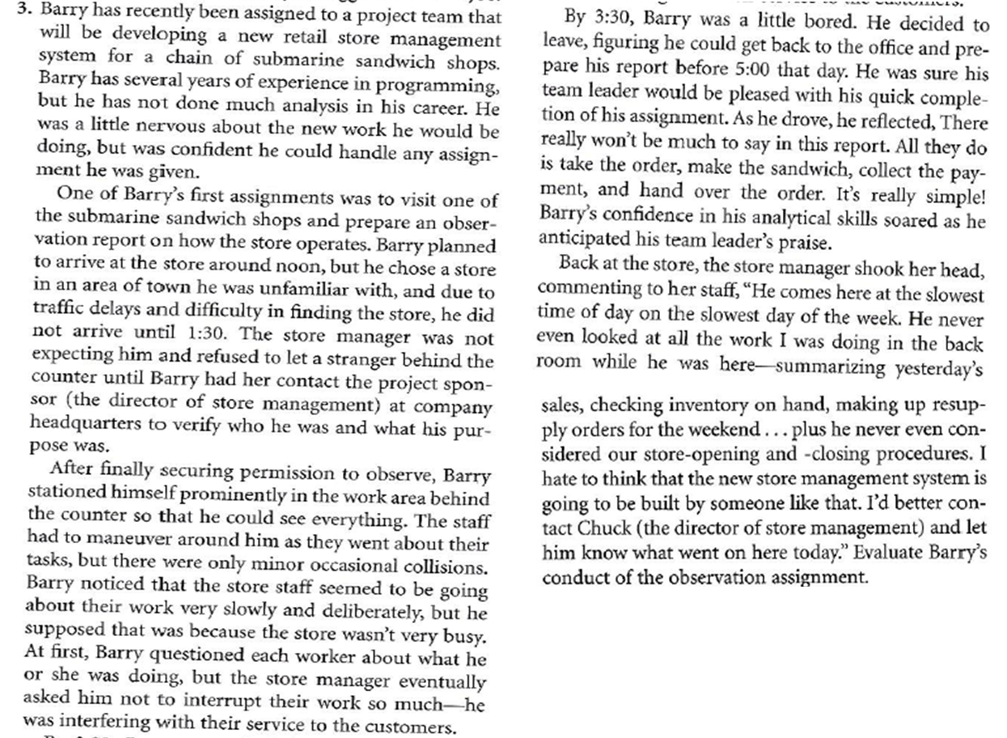

Barry did a very poor analysis of the whole current system in place. He looked at all the front end stuff because he’s used to being a customer and didn’t even think of the backend stuff. He obviously wasn’t remotely prepared for this task since he showed up so late and didn’t have a list of things he was supposed to be observing. He ended up frustrating the staff and manager, so it’s not like they’re very inclined to have him develop a system for them anymore either. Overall he did a poor analysis and came back with very little. It also never said he was writing things down, which is a big deal since that way he’s going to get back to the office and know generally what went down, but he’s not going to remember anything specific that he should put into the report. Barry should chose a different location where he knows the area better and go back wholly prepared to analyze their system, more aspects of it than just the front end.

1. Complete the following mini-case from page 152 of the Dennis textbook.

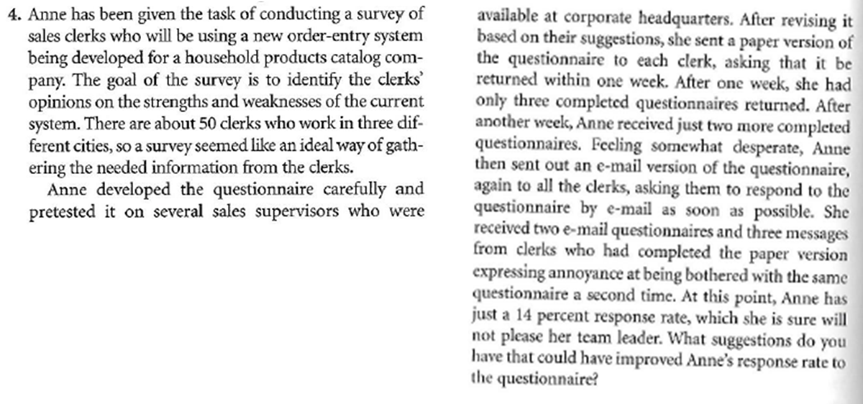

She should try and get the clerk’s attention by making sure they know that they benefit from the development of the new system for them. Include questions that they’d be interested in and include in the survey things that they don’t like about the system so that they can fix it. People are always up for talking about things that frustrate them, so knowing those things first could be a good way to get some information.

Part 3 – Identifying Requirements – Complete Individually

1. For each requirement, determine which type of non-functional requirement it describes. Indicate if it relates to operational requirements, performance requirements, cultural & political requirements, or security requirements.

|  |  |
| --- | --- |
| **Requirement Description** | **Non-Functional Requirement Type**  **(Operational, Performance, Security, Culture & Political** |
| 1. Help text will be provided in English, French and German. | Cultural and political |
| 1. All system data must be backed up every 24 hours and the   backup copies stored in a secure location which is not in the  same building as the system | Operational, security |
| 1. The “Update Customer” application is available 08:00 to 18:00 daily excluding Sundays and Public Holidays. | Operational |
| 1. Up to 500 users in total are supported. | Performance |
| 1. Customer data can be exported in XML format. | Operational |
| 1. Up to 300 users may be using the system at one time | Performance |
| 1. All changes to Customer data will be held for 6 years from the date of change. | Operational |
| 1. The “Update Customer” application will be licensed for 300 concurrent users. | Operational |
| 1. For American users all currency will be stored as USD | Cultural and political |
| 1. Changes required by law will applied at least 3 months before the law becomes enforceable. | Security |
| 1. During the process “Update Customer” system responses should be no more than 1 second. | Performance |
| 1. “Update Customer” will be available to users 98% of normal working hours. | Operational/Performance |
| 1. Only users holding the role “Customer Advisor” or “Supervisor” can access “Update Customer”. | Operational/Security |
| 1. The Customer Advisor Help desk will support users of “Update Customer” from 09:00 to 17:00 daily on weekdays only excluding public holidays. | Operational |

1. Identify each of the following as either **functional or non-functional requirements**. If the requirement is **non-functional, indicate if it relates to operational requirements, performance requirements, cultural & political requirements, or security requirements**, and identify the specific requirement, e.g. speed requirement within performance requirement.
   1. Teachers should be able to schedule the start and end times for a course evaluation.

**Nonfunctional- operational**

* 1. An email should be sent to a student within 5 minutes of requesting a password to be reset.

**Nonfunctional- performance**

* 1. Students should be able to evaluate their courses using portable hand held devices.

**Functional**

* 1. Users should have the ability to skip logic and branch conditionally when creating their questions for their course evaluations.

**Nonfunctional- operational**

* 1. Only teachers should be able to view the course evaluations for their course.

**Nonfunctional- Operational**

* 1. Dates should be identified using the YYYY-MM-DD format.

**Nonfunctional- culture and politics**

* 1. The system should be available 24/7 with the exception of scheduled maintenance.

**Nonfunctional- Performance**

* 1. Teachers should be able to select a template of questions for their course evaluations.

**Nonfunctional- Operational**

* 1. The course evaluation id should be encrypted in the url to prevent unauthorized access to a course evaluation.

**Nonfunctional- security**

* 1. The system will access the course and student enrollment data from the Clara database.

**Functional**

**Marking Scheme**

|  |  |
| --- | --- |
|  | Marks |
| Part 1 – Interview questions | 20 |
| Part 2 Question 1 | 7 |
| Part 2 Question 2 | 5 |
| Part 2 Question 3 – Mini case | 5 |
| Part 2 Question 4 – Mini case | 5 |
| Part 3 Question 1 | 13 |
| Part 3 Question 2 | 10 |
| Organization/English | 3 |
| Total | 68 |

**To submit**

When you have completed the exercise, upload the following documents to Moodle:

* **YourUserName_PartnerUserName_E11_L03_Interview_Questions.docx** (1 document per team)
* **YourUserName_E11_L03_Interview_Prep.docx** (individual)